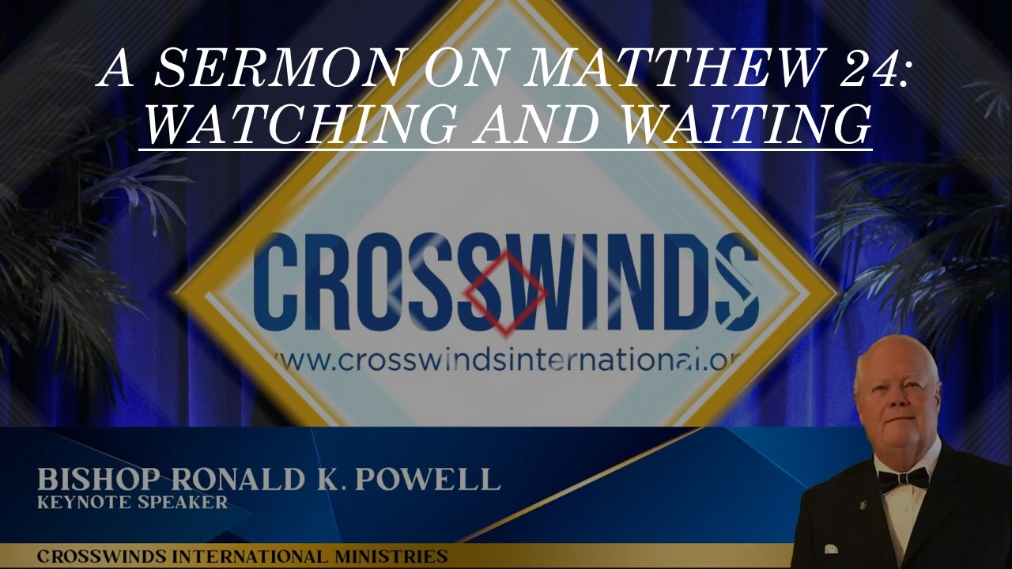

**Watching and Waiting**

* **“Then the disciples came to Him privately, saying, ‘Tell us, when will these things be, and what will be the sign of Your coming and of the end of the age?’**” **(**[**Matthew 24:3**](https://ref.ly/Matt%2024.3;kjv1900?t=biblia)**)**

In this pivotal chapter, Jesus addresses the disciples’ pressing question about the end times. His response, while filled with prophecies and warnings, ultimately points to a message of hope and vigilance.

* **The Imminent Yet Uncertain Return**  
  “But of that day and hour no one knows, not even the angels of heaven, nor the Son, but only the Father.” **(**[**Matthew 24:36**](https://ref.ly/Matt%2024.36;kjv1900?t=biblia)**)**  
  Jesus emphasizes the unexpected nature of His return. He likens it to a thief in the night, highlighting the importance of constant readiness. This doesn’t mean we should obsess over dates or predictions, but rather live each day with a sense of expectancy.
* **The Signs of the Times**  
  “For nation will rise against nation, and kingdom against kingdom. And there will be famines and earthquakes in various places. All these are the beginning of sorrows.” **(**[**Matthew 24:7-8**](https://ref.ly/Matt%2024.7-8;kjv1900?t=biblia)**)**

**While Jesus outlines various signs, such as wars, famines, and earthquakes,** He cautions against **false prophets and deceptive claims**. These signs are not merely future events, but rather a reflection of the brokenness and suffering that has always been present in the world.

* **In 2024 there were 19 Countries presently in wars or military conflicts. In 2024 there were 7 countries in Extreme Famine, and 1476 earth quakes above Magnitude5.0 or greater.**
* **The Need for Vigilance**  
  “Watch therefore, for you do not know what hour your Lord is coming.” **(**[**Matthew 24:42**](https://ref.ly/Matt%2024.42;kjv1900?t=biblia)**)**

**The overarching theme of Matthew 24 is the call to watchfulness.** Jesus urges His followers to be alert, discerning, and faithful. This vigilance isn’t about fear or anxiety, but rather a confident expectation of Christ’s return.

* **Living in Light of the End**  
  “Therefore, be on the alert, for you do not know when the master of the house is coming, in the evening, at midnight, at cock crowing, or in the morning.” **(**[**Matthew 24:42-43**](https://ref.ly/Matt%2024.42-43;kjv1900?t=biblia)**)**  
  How do we live in light of this imminent yet uncertain future?
* **Embrace a Life of Purpose:**

Knowing that Christ could return at any moment should motivate us to live each day with intention. Our actions, words, and thoughts should reflect the love and grace of God.  
Cultivate Spiritual Discipline: Regular prayer, Bible study, and worship deepen our relationship with Christ and strengthen our spiritual resolve.

* **Share the Gospel**:

As we await Christ’s return, we are called to share the good news of salvation with others. This is a tangible way to participate in God’s redemptive work.

* **Practice Acts of Love and Kindness:** In a world marked by division and hatred, let us be beacons of hope and compassion. By loving our neighbors and serving the marginalized, we demonstrate the love of Christ.

**In conclusion**,

**Matthew 24** is not a source of fear or despair, but a call to hope and action. As we navigate the uncertainties of life, let us remain steadfast in our faith, vigilant in our watchfulness, and eager for the glorious return of our Lord and Savior, Jesus Christ.